Laboratory Assignment AND Assessment Requirements Specification

Version 2.0

02 March, 2020

Developed by:

David Vlad-Alexandru

Gabor Ioana-Raluca

932

Version History

|  |  |  |  |
| --- | --- | --- | --- |
| Version | Description of Change | Author | Date |
| V01 | Initial configuration of the project | David Vlad  Gabor Ioana | 02 March, 2020 |
|  |  |  |  |

**Contents**

Contents

1 Functional Requirements 3

2 Use cases – diagram 4

3.1 Use case number 1 (Description of the use case) 5

3 Analysis 6

3.1 Entities 6

3.2 Relations between entities 6

3.3 Attributes 6

3.4 System behavior 6

3.4.1 Use case 1-2-3 6

4 Design 7

**Analysis and design Document**

# Functional Requirements

List the functional requirements (FR) of the system.

|  |  |
| --- | --- |
| Section/ Requirement ID | Requirement Definition |
| F0 | Implement CRUD operations for the Student entity |
| F1 | adding a laboratory theme |
| F2 | Extending the term of delivery for an existing subject (if the current week number is less than or equal to the number of weeks with the assignment deadline). |
| F3 | When adding a new laboratory theme, as well as modifying the delivery date of a theme, all students will be notified by email. The app will offer the ability to unsubscribe from these notifications |
| F4 | adding a grade for a particular student to a laboratory topic; any delays due to delays in delivery of a theme will be automatically calculated, showing the student's maximum mark on the topic. Important: A student, on a laboratory theme, has only one grade; |
| F5 | When adding a grade, the following information will be retained in the NameStudent.txt file: a "Theme:" ThemeNumber , "Delivered in the week:" NumberOfTheDeliveredWeek , "Deadline:" NumberOfDeadlineWeek , "Feedback:" feedback, suggestions, and explanations in connection with the reduced made regarding the grade. |
| F6 | The NameStudent.txt file (or its content) will be emailed to the student, weekly, with the subject "Feedback laboratory MAP". |
| F7 | The delays will not be considered if the student has motivation. Also, if the teacher did not enter the notes in time, it will be possible to specify the week in which the subject was delivered. - |
| F10 | Filtering entities based on criteria. |
| F11 | Reports |
| F11.1 | Laboratory grade for each student (the weighted average of grades from the lab topics; weight share = number of weeks allocated to the topic). |
| F11.2 | The hardest the theme: the average of the grades on the theme is the smallest. |
| F11.3 | Students who can enter the exam (average greater than or equal to 4). |
| F11.4 | Students who have delivered all the themes on time. |

**Actors**

The only actors from this application are the teacher (only they interact with the application).

# Use cases – diagram

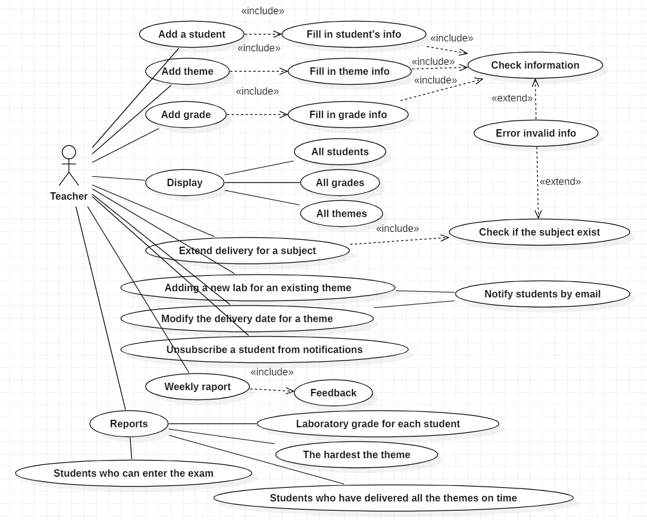

## Use case number 1 (Description of the use case)

Actors: Teacher

Description: Add student

Precondition: - valid student information (id, name, group)

Post condition: - repository size will increase with 1

Exceptions: When the fields aren’t filled.

|  |  |
| --- | --- |
| User action | Response |
| Complete the necessary fields | Check if everything is alright |
|  | Add student to repository |
|  | Display a corresponding message (success or failure) |

Actors: Teacher

Description: Add lab theme

Precondition: - valid lab theme information (lab number, description, deadline)

Post condition: - repository size will increase with 1

Exceptions: When the fields aren’t filled.

|  |  |
| --- | --- |
| User action | Response |
| Complete the necessary fields | Check if everything is alright |
|  | Add lab theme to repository |
|  | Display a corresponding message (success or failure) |

Actors: Teacher

Description: Add grade to a lab topic

Precondition: - valid grade information (theme number, number of the delivered week, number of the deadline week, feedback)

Post condition: - repository size will increase with 1

Exceptions: When the fields aren’t filled.

|  |  |
| --- | --- |
| User action | Response |
| Complete the necessary fields | Check if everything is alright |
|  | Add grade to repository |
|  | Display a corresponding message (success or failure) |

# Analysis

## Entities

Identify the entities: Nota, Student, Tema

## Relations between entities

Write the relations between the identified entities.

## Attributes

Write the attributes of the identified entities.

Nota:

1. id
2. idStudent
3. idTema
4. nota
5. data

Student:

1. idStudent
2. nume
3. grupa
4. email

Tema:

1. nrTema
2. descriere
3. deadline
4. primire

## System behavior

## Use case 1-2-3

The system will probably act as a subsystem to a larger environment, in order to speed up a certain process in the company’s workflow.

# Design

* 1. **Class diagram**
     1. **Curent package**

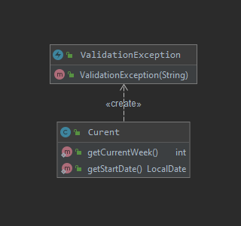

* + 1. **Domain package**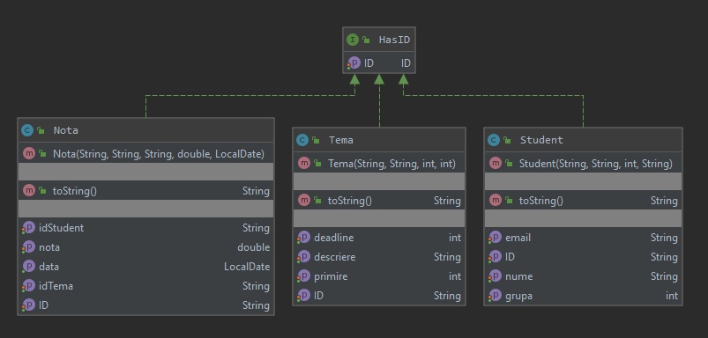
    2. **Repository package**

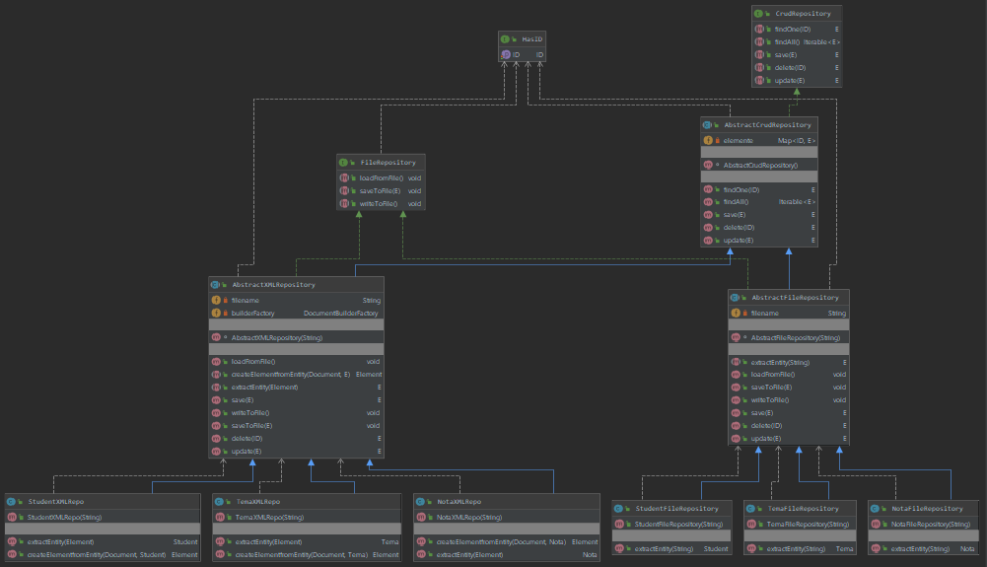

* + 1. **Service package**

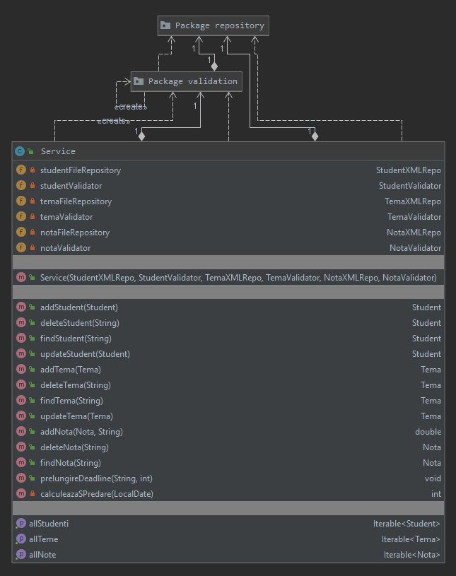

* + 1. **Validation package**

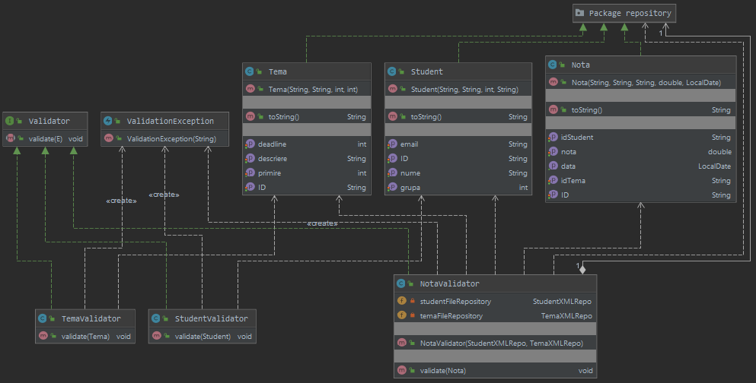

* + 1. **UI package**

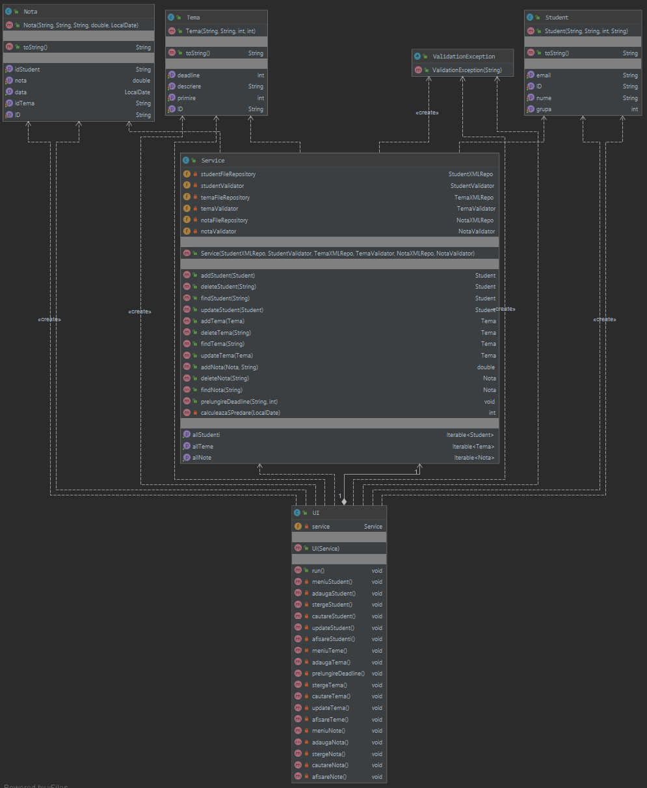

* 1. **Sequence diagrams (for each use case)**



 

